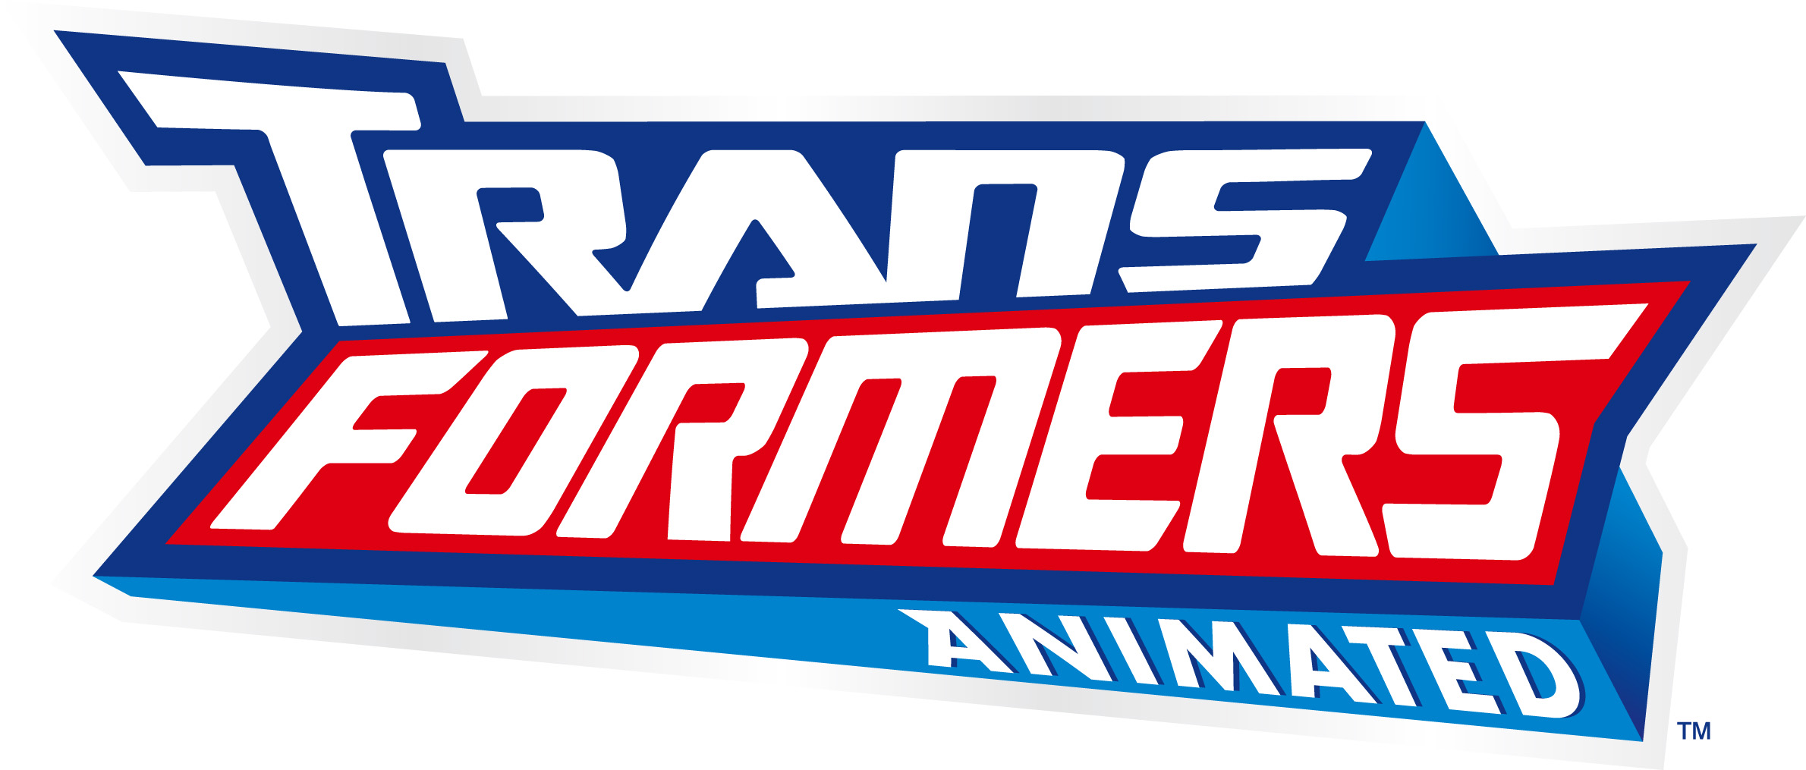

Voice Actor Biographies

David Kaye (the voice of OPTIMUS PRIME)
David Kaye is a man of a thousand voices and has worked professionally in the industry since the age of 16. Over the years Kaye has supplied vocal personalities to cartoon characters on series like G.I. Joe, G.I. Joe Extreme, StreetFighter: The Animated Series, Kong: The Animated Series, Exosquad, Stroker and Hoop, Fantastic Four Animated, X-Men Evolution and Inayusha. Kaye played the infamous Megatron on Beast Wars: Transformers, Beast Machines, Beasties and Transformers Armada. Over the past six years, Kaye has had lead, co-starring and guest starring roles in The Outer Limits, So Weird, The Sentinel, Viper, Dead Man's Gun, The Twilight Zone; features such as Carpool, Prisoner Of Zenda Inc., Dead Like Me and the TV movies Murder In My Mind, Ladies and the Champs, MVP II: Most Valuable Primate, and Live From Baghdad. He performed the lead role in The Love Charm, a half-hour independent film that won the Best Short Film Award at the Leo Awards in Vancouver.

Bumper Robinson (the voice of BUMBLEBEE)
Shortly after arriving in Los Angeles at the age of 4, Robinson began his career in entertainment in a national commercial for Jello Pudding Pops with Bill Cosby. He went on to do many more commercials, and his on-camera career developed quickly with roles in The Jeffersons, Hill St. Blues, Night Court, A Different World and Star Trek, Sabrina the Teenage Witch and CSI: New York. His feature film credits include Enemy Mine with Louis Gossett Jr. and Dennis Quaid. Robinson also has quite an extensive background in voice work having begun with a role in Hanna-Barbera’s Flintstone Kids cartoon, for which a character was actually developed in his own likeness. He went on to lend his voice to characters in The Teenage Mutant Ninja Turtles, Pinky and the Brain, Saban Entertainment’s What’s With Andy and Static Shock as well as voice work in the animated feature Brother Bear.

Bill Fagerbakke (the voice of BULKHEAD)
William “Bill” Fagerbakke is best known for his work as Assistant Coach “Dauber” Dybinski on Coach and in movies such as Funny Farm. He had a role as the mentally handicapped Tom Cullen in the 1994 miniseries Stephen King’s The Stand. In 1999, he had a recurring role on HBO’s original series Oz. Currently, Fagerbakke is known as the voice of Patrick Star on the SpongeBob SquarePants animated series.

Jeff Bennett (the voices of PROWL, Det. Fanzone, ULTRA MAGNUS)
In addition to his multiple roles in Transformers Animated, Bennett voices the role of Raj in Cartoon Network’s Emmy Award-winning series Camp Lazlo. His voice credits include the title role on Cartoon Network’s original series Johnny Bravo, as well as recurring roles in Class of 3000, Dexter’s Laboratory, The Powerpuff Girls, Histeria! and Where’s Waldo? Bennett lent his voice and sense of humor to Captain Hook’s loyal first mate, Smee, in Return to Neverland, as well as Animaniacs, Pinky and the Brain and Batman: The Animated Series.

Corey Burton (the voices of RATCHET, MEGATRON)
Corey Burton began his voice-acting career over 30 years ago, studying the craft of Radio Drama with the legendary Daws Butler (Yogi Bear). The San Fernando Valley native has voiced sound-alikes and original characters for hundreds of entertainment and educational productions and can be heard in any number of characterizations across the U.S. and Canada every day. Additionally, Burton has been a promo announcer for each of the major TV networks and a narrator on an eclectic assortment of documentaries. His TV animation voice credits span several popular Cartoon Network and Nickelodeon series along with Disney and Warner Bros. series. Theatrical film work includes most of Disney Feature Animation’s releases over the past two decades, appearing in the main cast ensemble as Moliere in Atlantis, and Cap’n Hook in Return to Neverland. He is also known for precision A.D.R./looping work featured in many prominent movies, such as E.T., Total Recall and Poltergeist films among others.

-more-

Tara Strong (the voice of Sari)
Tara Strong has given life to numerous cartoon characters in more than 50 animated series including the voice of Ben in Cartoon Network’s hit series Ben 10, as well as The Powerpuff Girls, Teen Titans, The Fairly OddParents, The Proud Family, Jakers!, Rugrats and The Rugrats: All Grown Up.

Tom Kenny (the voice of Sumdac, STARSCREAM)
Tom Kenny has created countless memorable characters on television. Kenny is the voice of Eduardo in Cartoon Network’s original series Foster’s Home for Imaginary Friends and the title character in SpongeBob SquarePants. His additional animated television credits include CatDog, The Powerpuff Girls, The Fairly OddParents, Futurama, Dexter’s Laboratory, Cow & Chicken, Johnny Bravo, Rocko’s Modern Life, Dilbert, What’s New Scooby Doo? and Xiolin Showdown. In addition, Kenny has lent his voice to the feature films Dr. Doolittle 2, Scary Movie 3, The Powerpuff Girls Movie and The SpongeBob SquarePants Movie.

