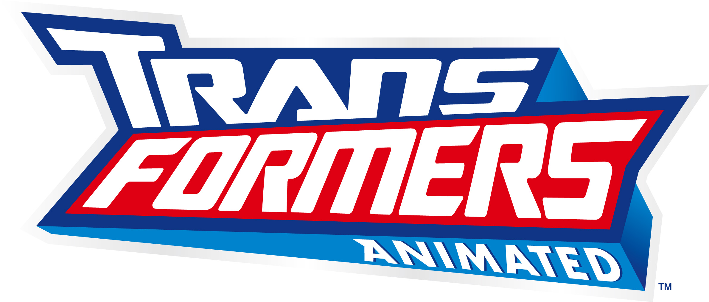

Episode Descriptions

Transformers Animated Special: "Transform and Roll Out" – OPTIMUS PRIME and his small crew of AUTOBOTS come into possession of the ALLSPARK, a powerful Cybertronian artifact that attracts the attention of their long-forgotten enemies the DECEPTICONS and sends them crashing to a strange and distant planet known as Earth.

“Home Is Where the Spark Is” – The AUTOBOTS settle into their new home base, an abandoned automobile manufacturing plant, but the ancient assembly line machinery seems to have developed a mind of its own.

“Total Meltdown” – A bio-engineering genius experiments with some hydraulic fluid from Bumblebee and accidentally morphs himself into MELTDOWN, whose corrosive touch can melt anything, including AUTOBOTS.

“Blast From the Past” – Professor Sumdac upgrades a trio of animatronic dinosaurs from a local theme park, but the creatures develop minds of their own and become rampaging DINOBOTS, bent on destroying the AUTOBOTS.

“Thrill of the Hunt” – While AUTOBOTS encounter a mysterious muscle car creating havoc in Detroit, RATCHET keeps flashing back to his “tour of duty” in the Great AUTOBOT-DECEPTICON Wars.

“Nanosec” – BUMBLEBEE calls himself the “fastest thing on wheels” and this self proclaimed title is threatened by NANOSEC, a super speedster crook on a deadly mission that could destroy all of Detroit.

“Along Came a Spider” – BUMBLEBEE and BULKHEAD experience their first Halloween which becomes spookier when they encounter a giant spider that turns out to be the deadly DECEPTICON BLACKARACHNIA.

“Sound and Fury” – Sari’s new toy musical robot seems to have an evil streak and the ability to control other machines, but BULKHEAD is the only one who sees it.

“Lost and Found” – The AUTOBOTS clash with DECEPTICONS LUGNUT and BLITZWING, who come to Earth searching for their missing leader MEGATRON.

“Survival of the Fittest” – Sari is kidnapped, and the evidence points to the DINOBOTS. So PROWL and BULKHEAD head to a mysterious island to investigate with a highly suspicious Captain Fanzone on their tail.

“Headmaster” – A disgruntled Sumdac employee seeks revenge and profit by taking control of one of the AUTOBOTS and sending him on a rampage.

“Nature Calls” – PROWL, BUMBLEBEE and Sari get more than the bargained for when they head out to the remote woods to investigate a mysterious energy signal.

“MEGATRON Rising, Part One” – OPTIMUS PRIME begins to doubt his leadership abilities as the DECEPTICONS mobilize for a big invasion of Earth.

“MEGATRON Rising, Part Two” – The AUTOBOTS are decimated by the DECEPTICON invasion, but still must rally to prevent the ALLSPARK from falling into their clutches.

