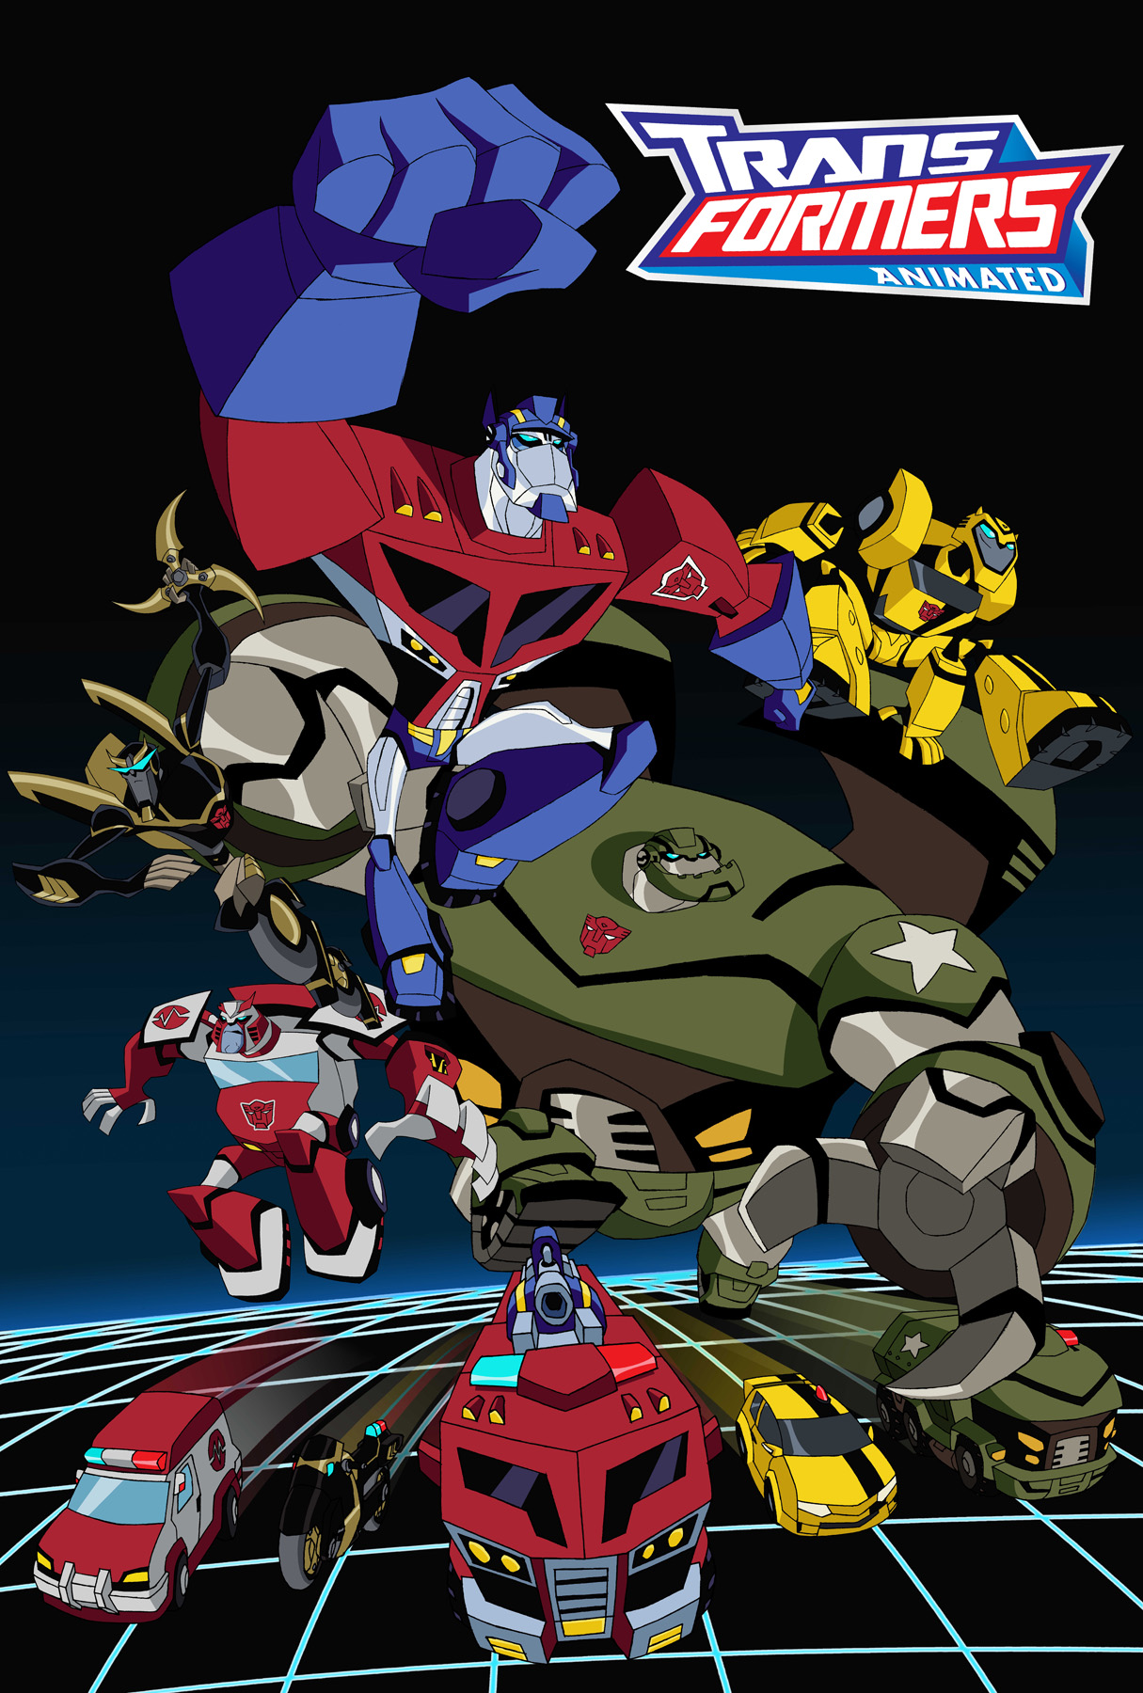

Fact Sheet

Launch Date:
TRANSFORMERS Animated Special : "Transform and Roll Out"
Wednesday, December 26, 2007 at 8 p.m. (ET, PT)

TRANSFORMERS Animated Series Premiere
“Home is Where the Spark Is”
Saturday, January 5, 2008 at 10:30 a.m. (ET, PT) *Regularly scheduled time period

Series Description:
Set on Earth in the near future in Detroit, the series begins when the alien TRANSFORMERS are thrust into a world populated by humans and automatons. As visitors to Earth, the TRANSFORMERS—OPTIMUS PRIME, BUMBLEBEE, PROWL, BULKHEAD and RATCHET—work in the human world, interacting with the “natives” in exciting and humorous ways. Following the AUTOBOTS across the galaxy to their new home is the megalomaniacal MEGATRON and his army of ruthless DECEPTICONS, a brutal race of war-mongering robots who seek to use the ALLSPARK as their ultimate weapon of destruction!

The AUTOBOTS’ unlikely guide through Earth society is a brash, energetic 8-year-old girl named Sari Sumdac, the adopted daughter of a robotics magnate. Setting the AUTOBOTS up with their headquarters in an old abandoned auto plant on the outskirts of town, Sari not only becomes an “honorary AUTOBOT” by enlightening them on mysteries of Earth life such as megamalls, holovision, hoverboards, junk food, and basic hanging out, but she also becomes a vital component of the team in their adventures. For the ALLSPARK endows Sari with a very special power, one the DECEPTICONS would love to get their hands on—not to mention the ALLSPARK itself.

Voice Talent:
OPTIMUS PRIME: David Kaye
BUMBLEBEE: Bumper Robinson
BULKHEAD: Bill Fagerbakke
PROWL: Jeff Bennett
RATCHET: Corey Burton
MEGATRON: Corey Burton
Sari: Tara Strong
Sumdac: Tom Kenny
STARSCREAM: Tom Kenny
Det. Fanzone: Jeff Bennett
ULTRA MAGNUS: Jeff Bennett

Production:
Executive Producer: Sam Register
Supervising Director: Matt Youngberg
Head Writer: Marty Isenberg
Character Designer: Derrick Wyatt

