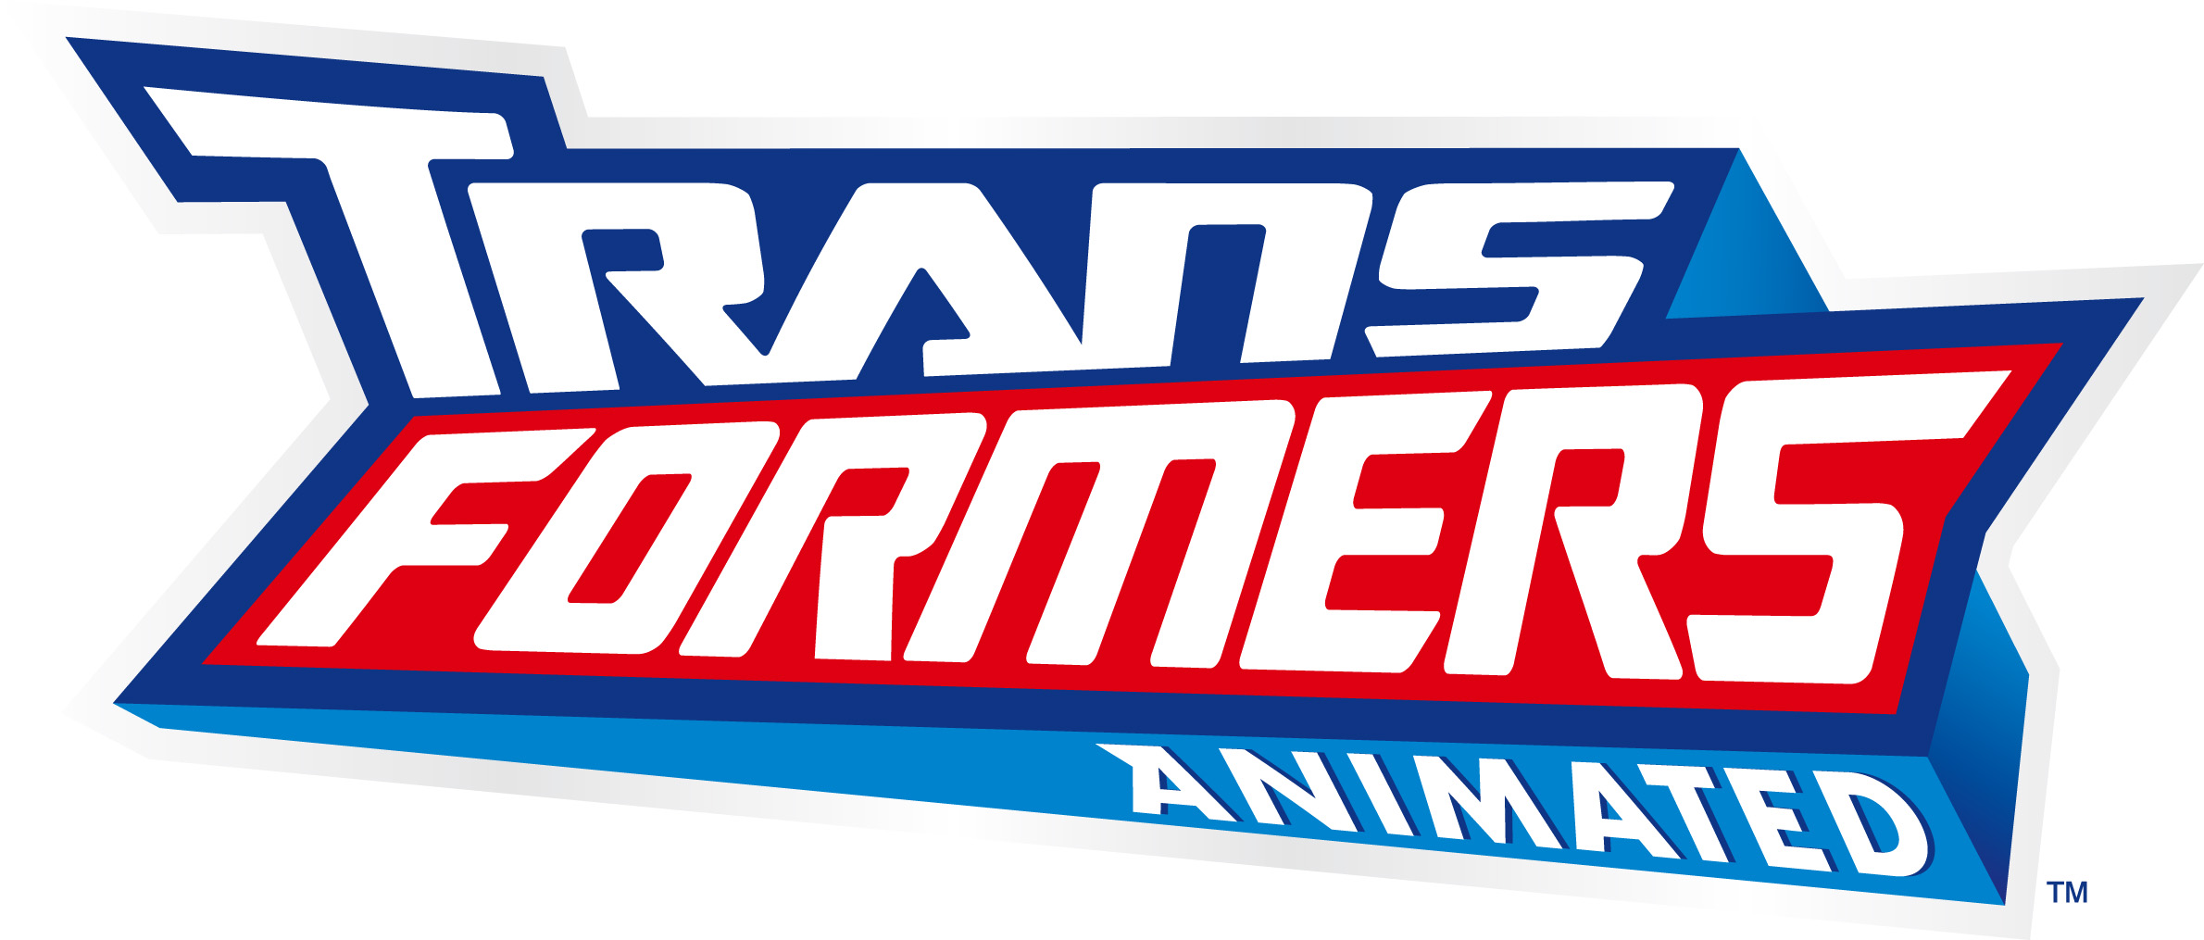

CHARACTER DESCRIPTIONS

“Humans”

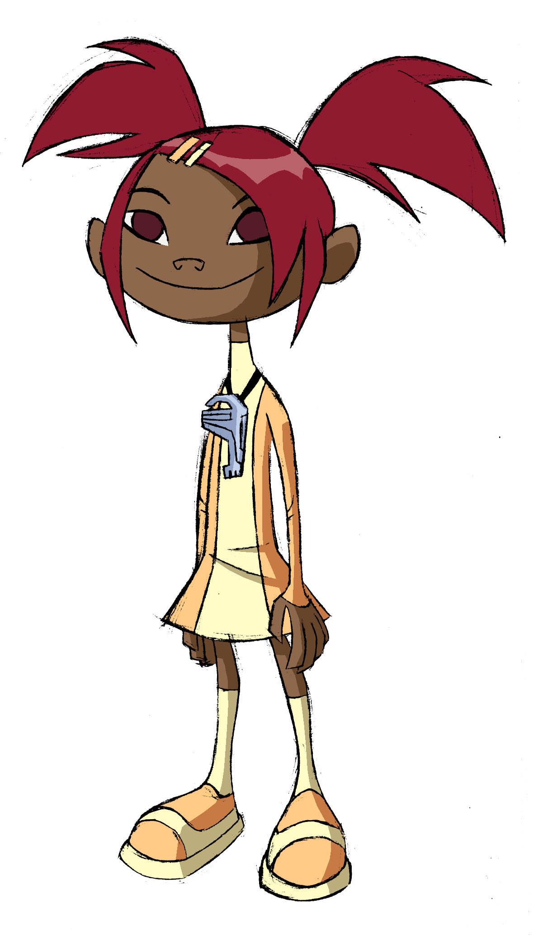

SARI SUMDAC
(Voiced by Tara Strong)

Although Sari is one hundred percent human, she’s an “honorary” AUTOBOT. As the adopted daughter of robotics magnate Isaac Sumdac, Sari lived a sheltered life until she met the AUTOBOTS. Obsessed by his work, Sumdac had little time for Sari growing up. As a result, she was raised largely by his domestic robot drones, whom little Sari came to love as deeply as any parent, nanny, teddy bear and/or imaginary friend.

Sari is also integral to the survival of the AUTOBOTS. When they first awakened on Earth, the ALLSPARK scanned for technology that would allow the AUTOBOTS to blend in with their environment. But it scanned something else first: an organic life form—specifically, a pre-pubescent girl who was hanging around her father’s robotics factory. Call it an accident or call it destiny, but the ALLSPARK projected part of itself onto Sari in the form of THE KEY. Wearing it on a chain around her neck, Sari can use the Key to absorb the ALLSPARK energy and store it like a battery, providing an emergency power supply and healing source for the AUTOBOTS in battle. It also provides Sari with an almost psychic connection to the AUTOBOTS. She can sense when they’re in danger and when DECEPTICONS are near.

Sari acts as the unofficial ambassador to the planet Earth for the AUTOBOTS, cluing them in on such alien concepts as junk food, school, sleep, popularity, shopping, belching contests, fashion and the dreaded tow away zones.

-more-

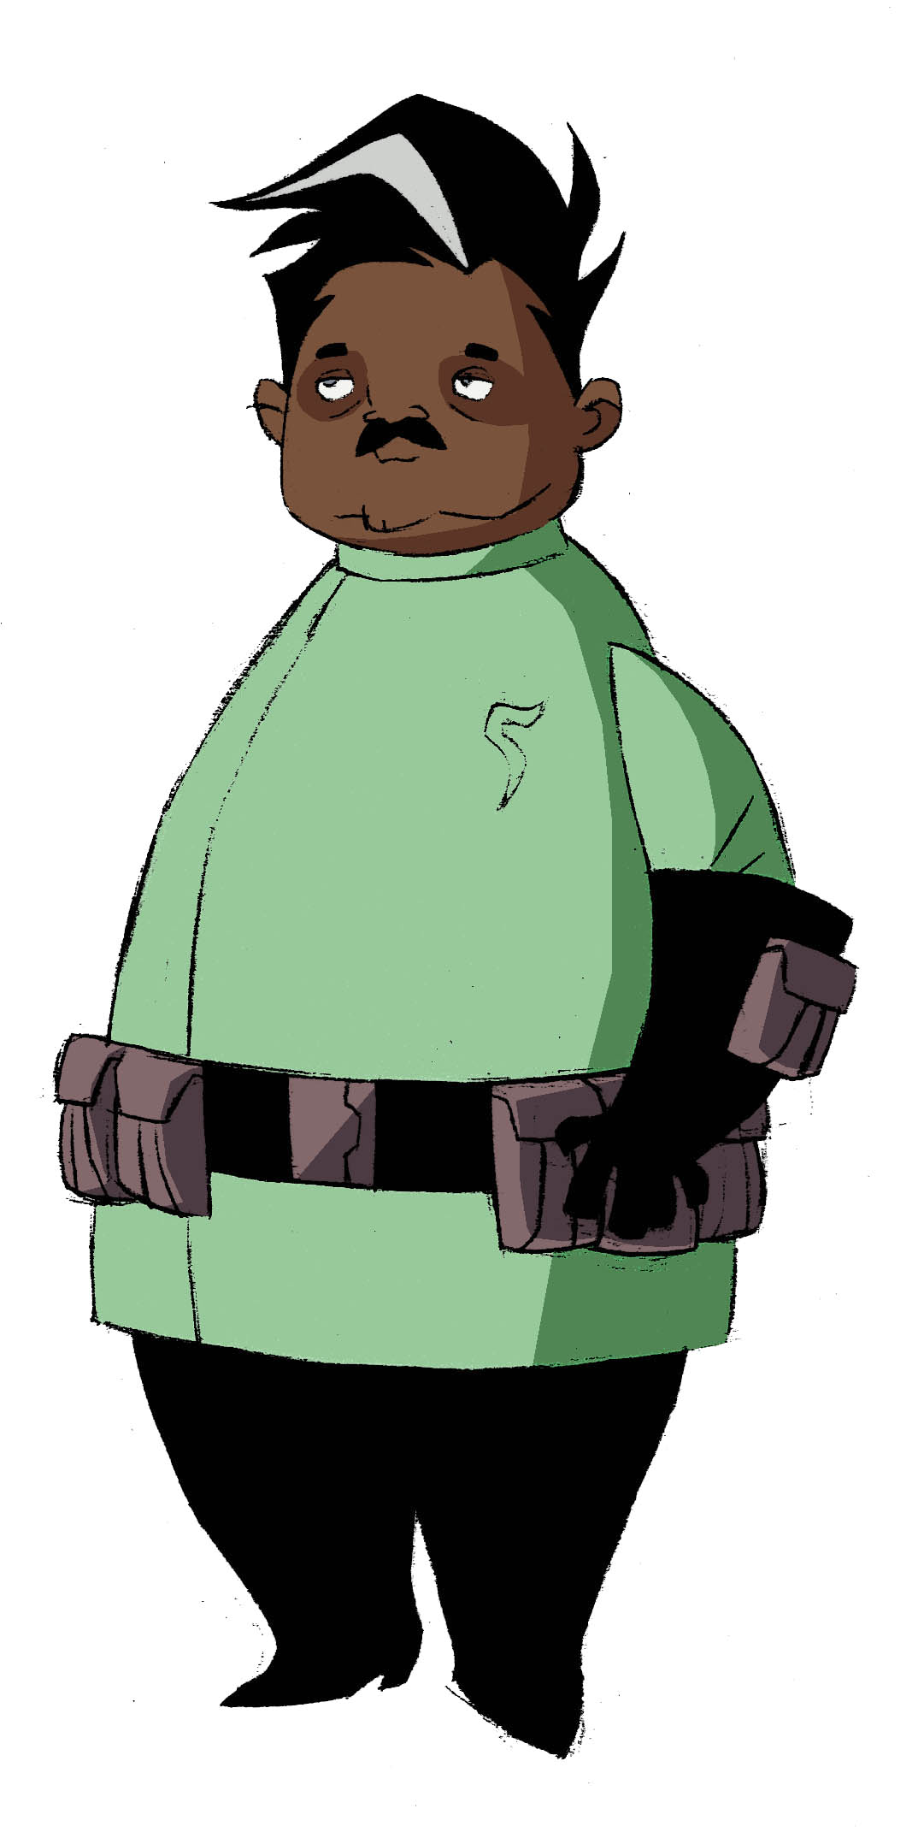

ISAAC SUMDAC
(Voiced by Tom Kenny)

As the founder of the modern robotics industry, Sumdac single-handedly transformed the city of Detroit from the crumbling symbol of a declining automobile industry to the gleaming, thriving beacon of the future it becomes in the 22nd Century. And his public awe and deep gratitude toward the AUTOBOTS is largely responsible for their elevated superhero status on Earth.

One night in the late 21st Century, the young Sumdac thought he saw a falling star cascade into his back field, but it was something much better. It was the smoldering, non-functioning remains of the head of an alien robot, Megatron. Turns out, after his battle with OPTIMUS PRIME and the AUTOBOTS, a badly damaged Megatron ejected from his ship and crashed to Earth, landing in Sumdac’s field. In the decades that passed while the AUTOBOTS slumbered in stasis at the bottom of Lake Erie, Sumdac was able to reverse the Cybertronian technology engineered by Megatron and usher in the Automatronic Revolution of the 22nd Century.

But what Sumdac doesn’t know is that the remains of the cybernetic alien he recovered may be more functional than they appear. And Megatron has been manipulating Sumdac to bring Earth technology to a level that will allow him to reconstruct his battle damaged body and a whole new army of DECEPTICONS.

-more-

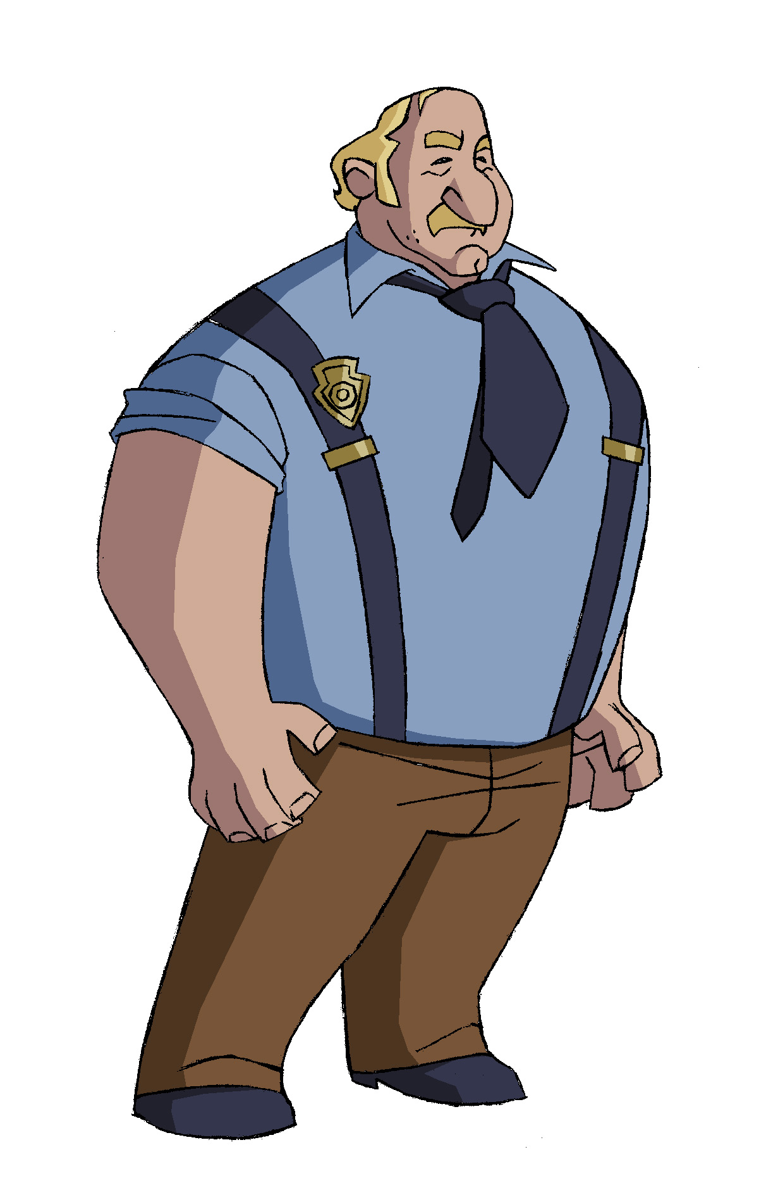

CAPTAIN FANZONE
(Voiced by Jeff Bennett)

Captain Fanzone is not an AUTOBOT, but a police detective whose car was scanned to become the vehicle mode for BUMBLEBEE. He’s a harried, overworked, but basically good and honest cop, albeit one whose day is perpetually ruined by one of those “giant walking toasters” (especially BUMBLEBEE, who has the audacity to run around looking like his car). A ludite at heart with old-fashioned tastes for vinyl records, old cars and analogue everything), Fanzone prefers the stairs to the elevator, walking to the people-mover, talking face-to-face over IM-ing, etc. Technology constantly confounds him, everything from the snack machine to the forever malfunctioning Sumdac Security Drones he’s forced to work with.

