

CHARACTER DESCRIPTIONS

“DECEPTICONS”
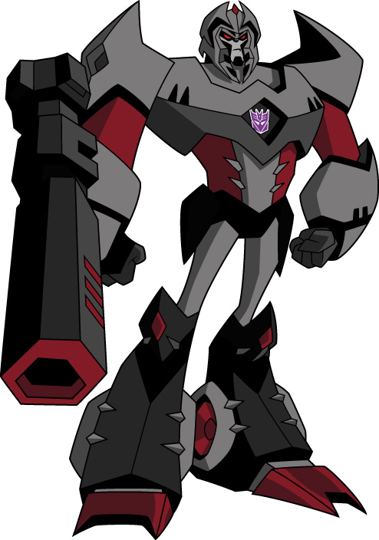

MEGATRON
(Voiced by Corey Burton)

MEGATRON is a fierce, unyielding despot who sees himself as a freedom fighter. He sees the DECEPTICONS as an oppressed race suffering under the tyranny of the AUTOBOTS. The DECEPTICONS must survive by any means necessary. He takes extreme pleasure in the suffering of even a single Autobot. And MEGATRON does not care at all for the collateral damage known as humans who might happen to stand in his way. He has the zeal of a fanatic and demands the unquestioning loyalty of those who serve him.

Robot Mode Power: MEGATRON begins the series with only one power: the power to lie and manipulate Sumdac to repair and reconstruct him. Over time, the MEGATRON head will develop into a powerful psychokinetic who can control any machine. While the Cybertronian minds are too advanced to succumb to this ability, MEGATRON can control virtually any robot on Earth and the automated plants that construct them. In addition to this power, MEGATRON’s eventual robot body will be equipped with an assortment of laser cannons, sonic missiles and pulse blasters.

Vehicle Mode Appearance: Helicopter Gunship.

-more-

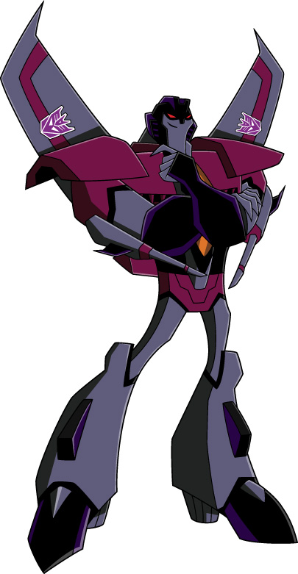

STARSCREAM
(Voiced by Tom Kenny)

While most of the DECEPTICONS viewed MEGATRON’s defeat and seemingly extinguished spark as a blow to their cause, STARSCREAM viewed it as an opportunity for his own cause. STARSCREAM has always lived in MEGATRON’s shadow, and it burns him constantly. He feels he’s done as much if not more than MEGATRON in the name of the DECEPTICON cause, but he simply lacks MEGATRON’s charisma to inspire others to follow him. STARSCREAM makes up for this failing with lies, deceit, manipulation and when all else fails…MORE lies, deceit and manipulation. STARSCREAM would love nothing more than to obtain the ALLSPARK himself, win the devotion of the DECEPTICONS and usurp MEGATRON’s rule. He’s driven by jealousy, pure and simple. A Machiavellian manipulator who never met an ally he wasn’t willing to stab in the back to get what he wants.

Robot Mode Power: STARSCREAM has incredible speed, maneuverability, and hovering capabilities. He can fly rings round the AUTOBOTS. In addition, he can affect a sonic scream and produce powerful blasts of sound that can send enemies spinning through the atmosphere.

Vehicle Mode Appearance: Harrier Jet.

-more-

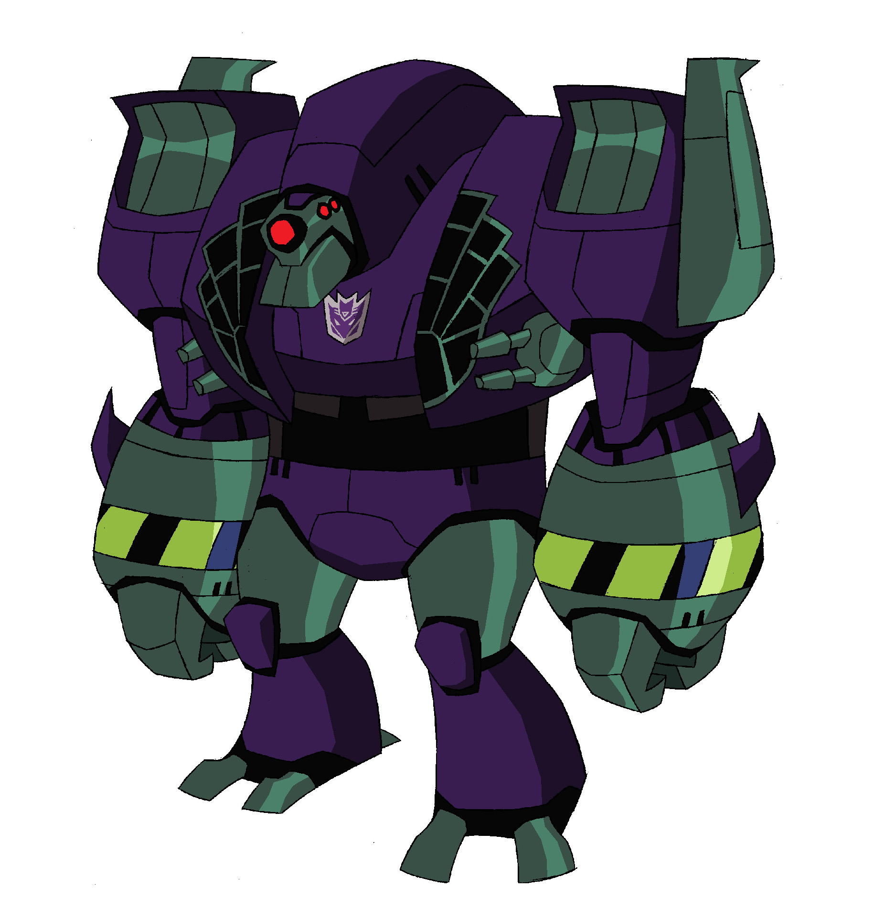

LUGNUT
(Voiced by David Kaye)

LUGNUT is more a force of nature than a DECEPTICON. MEGATRON’s fiercely loyal but none-too-bright attack dog. He would gladly follow his leader into the depths of hell. Of the DECEPTICONS, only LUGNUT refuses to believe that MEGATRON is gone for good. When we first meet him, LUGNUT has devoted his life to preserving his beloved leader’s memory and vanquishing his foes. LUGNUT deems himself and any other DECEPTICON unworthy to take the mantle of leadership. Personality-wise, LUGNUT comes across as a cross between a pit bull, a Klingon and a manic street preacher.

Robot Mode Power: LUGNUT is incredibly strong, the Hulk to BULKHEAD’s Thing. He also carries a payload of mega-bombs and can spew liquid napalm with laser-like accuracy. But he much prefers to rip things apart with his bare hands.

Vehicle Mode Appearance: Supersonic Bomber.

-more-
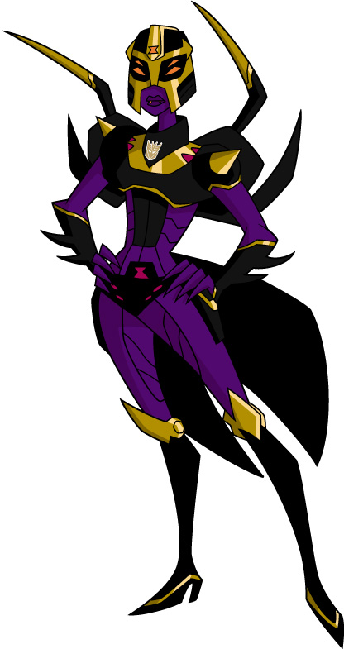

BLACKARACHNIA
(Voiced by Cree Summer)

BLACKARACHNIA is a freak among DECEPTICONS. Some time back, an encounter with the ALLSPARK caused her to fuse with an organic spider, turning her into a techno-organic hybrid of animal and machine. She despises this new form, especially on Earth, where her giant spider mode doesn’t exactly allow her to “blend.” BLACKARACHNIA will do anything to find a cure for her condition and doesn’t care who she has to step on to get it. Obviously the ALLSPARK and its Autobot protectors will play a big role in her schemes.

Robot Mode Power: BLACKARACHNIA has multiple eyes and eight limbs – two of which are skinny, pincer-like “spider limbs” that jut from her back and arc over her shoulders. The pincer limbs can strike like scorpions’ tails, stunning prey with her venom, or spraying spider-like webs. She also has the ability to download and temporarily absorb other Cybertronians’ powers.

Vehicle Mode Appearance: BLACKARACHNIA has no vehicle mode appearance. Instead she changes into a giant techno-organic black widow spider.

-more-
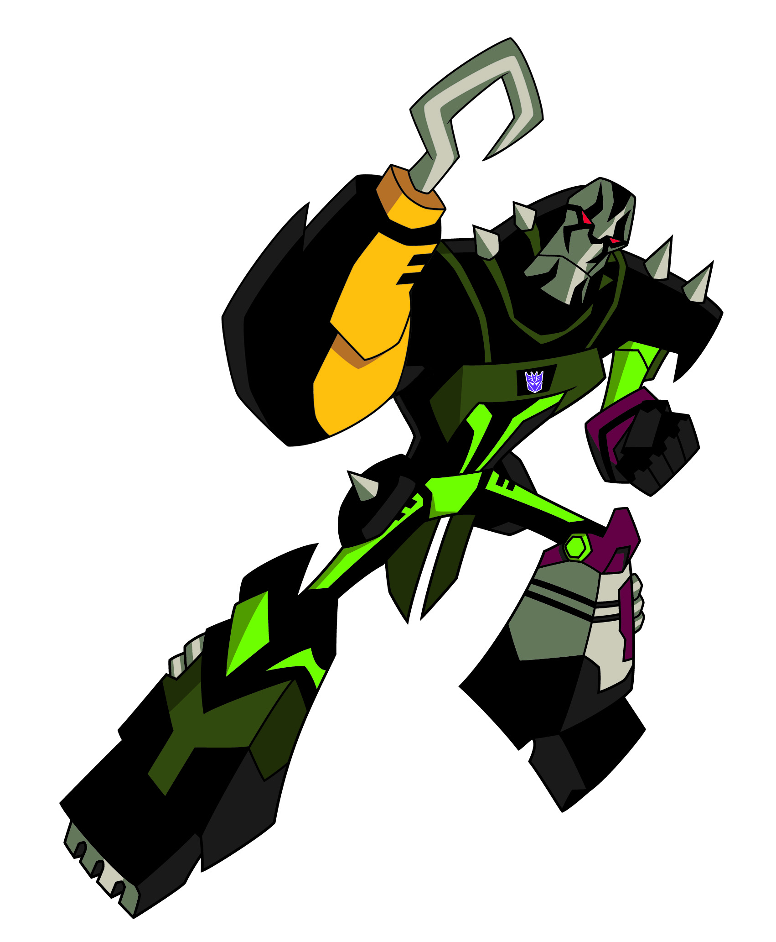

LOCKDOWN
(Voiced by Lance Henrikson)

A sleek stealth fighter, LOCKDOWN is a skilled hunter and tracker who can blend into nearly any environment. He lives for the hunt and for the thrill and challenge it provides. He has no strong allegiance to MEGATRON or the DECEPTICONS, but is more than willing to hire himself out as a Mercenary/Bounty Hunter.

Robot Mode Power: LOCKDOWN is outfitted with all kinds of high-tech weaponry befitting a robot hunter – bolos, snare nets, electronic stun darts (which can prevent mode changes), etc. He also can go into a Predator-like stealth mode for brief periods.

Vehicle Mode Appearance: Muscle Car.
-more-

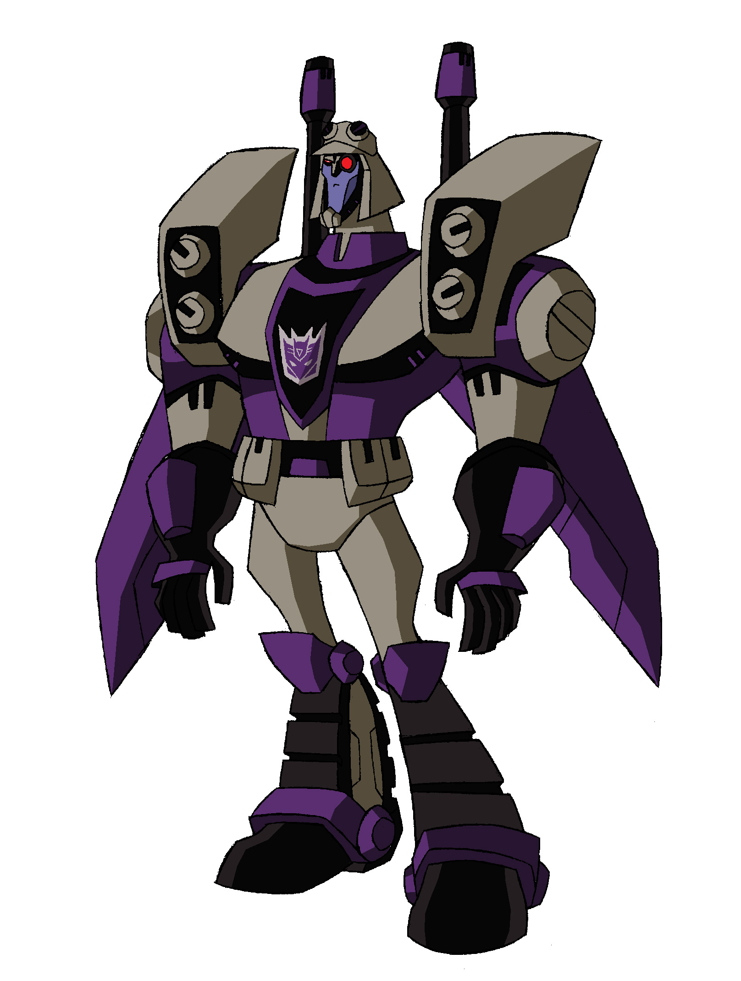

BLITZWING
(Voiced by Bumber Robinson)

The “Joker” of the DECEPTICONS. An unpredictable “triple changer” multiple personality bot, driven mad by his constantly shifting appearance. He has three personalities, one for each face, and his power depends on the face: Icy, cold and calculating; Hothead, short tempered, volatile; and Random, completely bonkers.

Robot Mode Power: BLITZWING is a “triple-changer”—that is, he has three modes (one robot, two vehicles). Plus he has three faces, each with its own personality. His power depends on which face he’s showing. Heat/flame, cold/ice or completely random.

Vehicle Mode Appearance: Jet and Tank.

