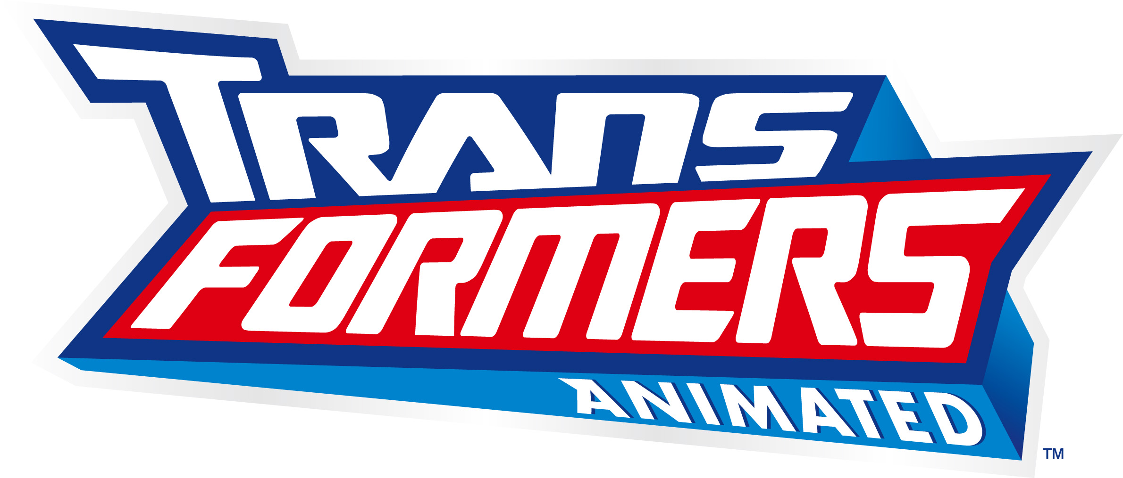

CHARACTER DESCRIPTIONS

“AUTOBOTS”

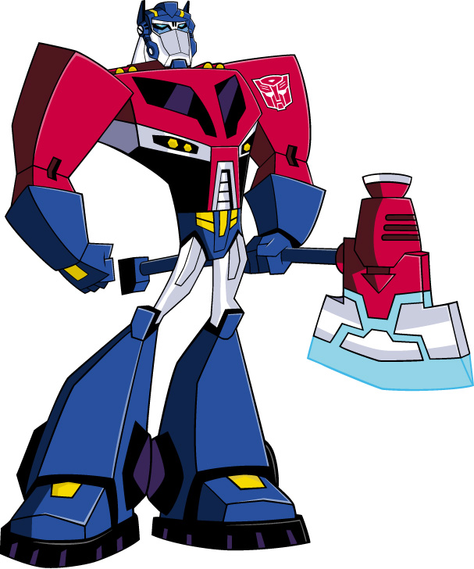

OPTIMUS PRIME
(Voiced by David Kaye)

OPTIMUS PRIME is a young (by Cybertronian standards) commander of a ragtag and largely inexperienced group of misfit AUTOBOTS. He’s a born leader, a natural tactician, a dedicated never-say-die fighter and a master of improvisation in the face of adversity. Unassuming, humble, friendly and cheerful, Prime comes across as “The Bot Next Door.” He takes his mission and his men with the utmost seriousness, but is still able to relate to them as a regular guy. He’s not the kind of leader who needs to bark orders to command respect (besides, he’s got RATCHET to do that for him).

Robot Mode Power: OPTIMUS PRIME has the ability to change any part of his robotic body into a tool or gadget. His arsenal includes a jet-powered axe, grappler and fire extinguisher.

Vehicle Mode Appearance: Fire Truck.

-more-

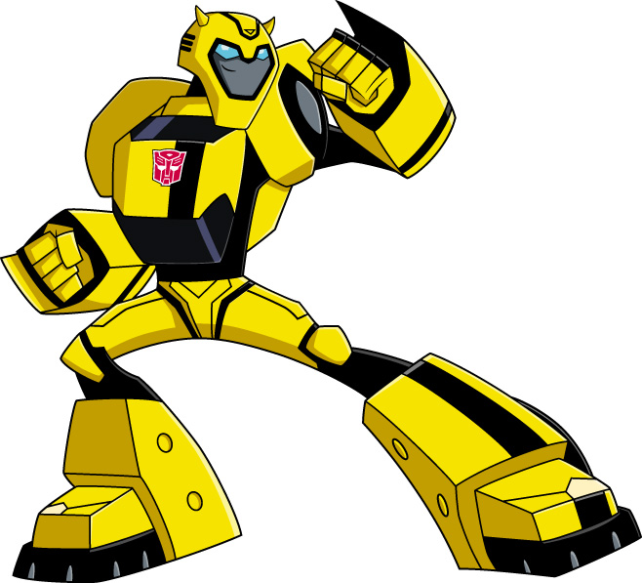

BUMBLEBEE
(Voiced by Bumper Robinson)

BUMBLEBEE is the “kid” of the team, easily the youngest and the least mature of the AUTOBOTS. He’s over-eager, over-confident and constantly overcompensating for his diminutive stature. Fast-talking, wise-cracking, scheming and hyperactive, BUMBLEBEE is not nearly as cool as he imagines himself to be. Then again, nobody could possibly be as cool as BUMBLEBEE imagines himself to be. He’s a total showoff, always acting on impulse and rarely considering the consequences. And he’s always getting in way over his head, although most things are way over his head. But don’t mention that to BUMBLEBEE; he’s very sensitive about his height.

Robot Mode Power: BUMBLEBEE can create electric force “stings,” allowing him to stun enemies or blast his way through whatever’s in his path. He’s also the fastest of the AUTOBOTS, in both vehicle and robot mode.

Vehicle Mode Appearance: Compact Police Detective’s Car.

-more-

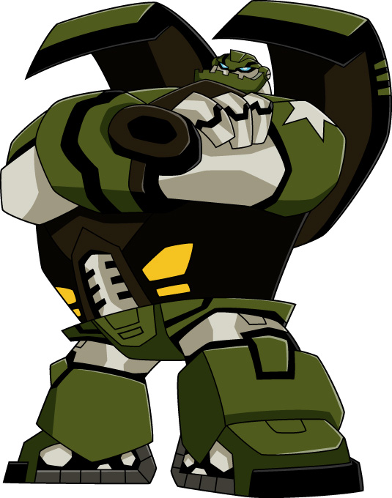

BULKHEAD
(Voiced by Bill Fagerbakke)

Every team needs its “muscle” and BULKHEAD is it. Designed primarily for demolition, BULKHEAD is a bull in a china shop, whether he wants to be or not. In battle, he’s your greatest weapon. Everywhere else… well, hide the breakables. He’s not overly clumsy, but he’s like a big overly enthusiastic dog who doesn’t know his own size or strength. BULKHEAD has a natural curiosity about humans and their culture. He’s especially interested in art, something that doesn’t exist on Cybertron. On some level the creative urge is an attempt to compensate for all the destruction—deliberate or inadvertent – that he causes. Problem is, most of his “creations” either fall apart, don’t look a thing like what he says they are, or are just plain ugly. Not that anyone would ever tell BULKHEAD that to his face.

Robot Mode Power: BULKHEAD is easily the strongest of the AUTOBOTS. That combined with battering ram arms make him the ultimate “Demolition Bot.”

Vehicle Mode Appearance: S.W.A.T. Assault Vehicle.

-more-
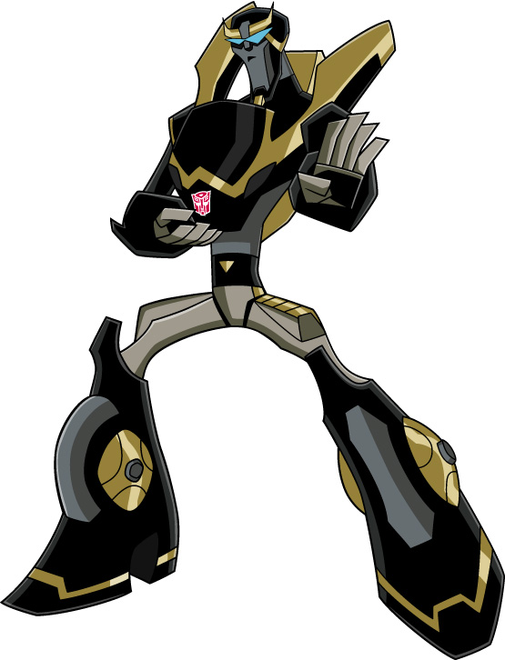

PROWL
(Voiced by Jeff Bennett)

PROWL is dark, sleek, agile, mysterious, and the ninja of the team. He speaks only when he has to, and even then as briefly as possible. Of all the AUTOBOTS, he’s the most skilled in direct combat. A natural spy, PROWL can infiltrate most any location unseen and unheard, so he’s used for reconnaissance more than any other Autobot. He is a bot of very little talk and much action. He’s unflappable, precise and has developed a keen interest in organic life.

Robot Mode Power: PROWL is an expert in camouflaging himself. He can turn virtually any object into a weapon. He also has keener senses—higher rez everything—than the other AUTOBOTS.

Vehicle Mode Appearance: Police Motorcycle.

-more-

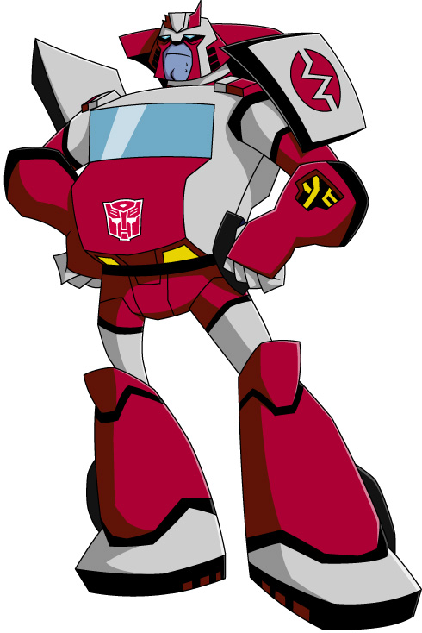

RATCHET
(Voiced by Corey Burton)

Short-tempered, grizzled and seemingly older than the ALLSPARK itself, RATCHET is the team’s medic and OPTIMUS PRIME’s occasional drill sergeant/second-in-command. He’s an expert healer, but his bedside manner leaves a lot to be desired. Spend two minutes with RATCHET and you instantly get the sense that this bot’s seen it all. RATCHET largely keeps his past to himself, dishing out tantalizing tidbits when he feels the “kids” can handle, or NEED to handle, some of the truth.

Robot Mode Power: RATCHET has magnetic powers. He can attract and repel any metallic matter or create magnetic force fields. He also uses these powers as the team’s medic, reshaping metal and circuitry, patching up any of the AUTOBOTS in the field. His talents also make him the team’s gadget-head. He can configure any tech they need and even perform robot/vehicle upgrades for all the AUTOBOTS.

Vehicle Mode Appearance: Tactical Medical Response Vehicle.

